Kaplan Martinez
ITAI1378
LO6 Journal/Reflective questions:
Journal:
Lab 06 moved from simple image classification to Object Detection. Using a pre-trained Faster R-CNN model, I learned how to not only identify objects but also locate them using bounding boxes. The key technique was Transfer Learning, where we used a model already trained on the COCO dataset. This saved a lot of time since the model already "knew" how to recognize basic shapes and textures.
Compared to the "Chihuahua vs. Muffin" lab, object detection is much more complex because it handles localization. While my previous CNNs gave one label for a whole image, this model can find multiple objects in a crowded scene. I used Confidence Scores to filter out weak guesses and Intersection over Union (IoU) to measure how accurately the predicted boxes overlapped with the real objects.
My biggest challenge was understanding the bounding box coordinate system ([x_min, y_min, x_max, y_max]). It was hard to visualize those numbers as a rectangle at first, but studying the visualization code helped. I also had to experiment with the score threshold; setting it too low made the image messy, while setting it too high made the model miss things. I solved this by testing different levels until the results looked clean.
This technology is perfect for Warehouse Inventory (automatically counting items) or self-driving cars. However, there are big ethical concerns regarding privacy and surveillance. We also have to be careful about Dataset Bias, because if a model isn't trained on diverse images, it might fail or be unfair in certain real-world situations.
This lab felt very practical because I could actually see the model "working" in real-time. It was a step up in difficulty from the earlier labs, but using transfer learning made it manageable and gave me great ideas for future projects.
Reflective questions:
1.
- Image classification is just about labeling the whole picture (like saying "this is a dog"). Object detection is more detailed because it labels the objects and also draws a box around them to show exactly where they are in the image.
2.
- We use fractions (normalized coordinates) so that the bounding boxes are independent of the image's resolution. If you use exact pixels, the coordinates would break if you resized the image. By using 0 to 1, the box stays in the same relative spot whether the image is tiny or huge.
3.
- IoU measures how much the box the model predicted overlaps with the actual "real" box. It’s basically the area where they overlap divided by the total area of both boxes combined. We use 0.5 as a common threshold because it’s the standard "pass/fail" mark, if more than half of the area overlaps, the detection is usually considered "good enough" for most basic tasks.
4.
- The hardest part of implementing display_examples or plot_detections was mapping those 0-to-1 fractions back into real pixel values. To solve this, I had to multiply the normalized coordinates by the actual width and height of the image before drawing the rectangle, otherwise, the boxes would all just show up as tiny dots in the top-left corner.
5.
- In the code, you first find the coordinates for the intersection area by taking the maximum of the top-left corners and the minimum of the bottom-right corners. If I forgot to use max (0, ...) for the width and height, and the boxes didn't overlap at all, the math would result in a "negative" width. This would create a negative area and completely break the final IoU score.
6.
- The only encounter where I had errors was from the first code bloack we were instructed to do based off of the canvas assignment. From using the GPU, after copying and pasting the code, there was an error in a space from the “if” function and indention issues. That was resolved with accordingly after taking a closer look.
7.
- When I used threshold=0.3, I saw way more boxes because the model was being "loose" and showing everything it was even slightly sure about. With threshold=0.7, most of those extra boxes disappeared, leaving only the ones the model was very confident in. I think 0.7 is usually better because it gets rid of the "noise" and fake detections, though you might miss some smaller objects.
8.
- When you increase the IoU threshold (making the test stricter), both Precision and Recall typically go down. Increasing the IoU threshold is like shrinking the bullseye on a target; it becomes much harder to "score," so both your success rates go down. And the opposite for decreasing.
9.
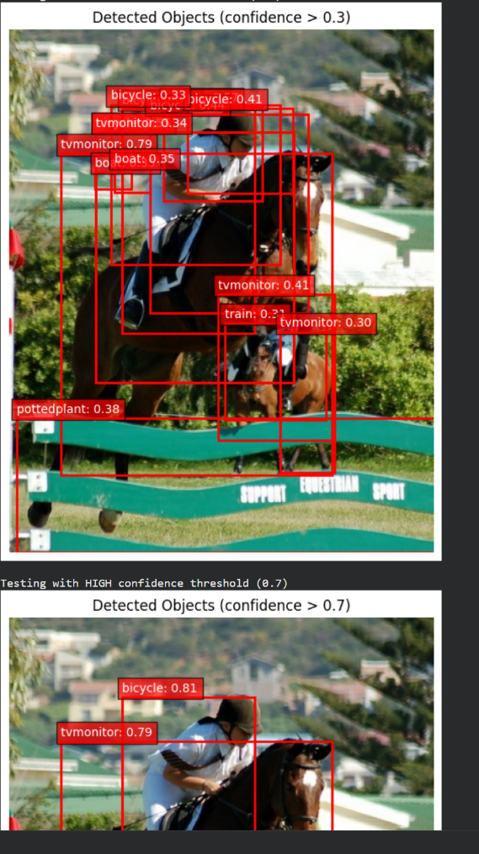
- False Positive: The model might detect a "person" that is actually just a vertical pole or a shadow. This usually happens because the model sees a shape that looks similar to its training data but lacks enough detail to tell the difference.
- False Negative: The model might miss a car if it's partially hidden behind a tree (occlusion). This happens because the model can't see the full "signature" of the object, so it doesn't meet the confidence threshold to draw a box.
10.
- Self-Driving Car: You should prioritize High Recall. It is much safer for the car to brake for a "ghost" pedestrian (false positive) than to miss a real person (false negative) and cause an accident.
- Photo App: You should prioritize High Precision. Users will find it annoying if the app incorrectly tags their mom as a "tree," but they likely won't mind if it just misses one or two background objects.
11.
- Advantages: It's incredibly fast and doesn't require a massive computer or a giant dataset to get started. You can get professional-level results in minutes. Spending time in training a model would be dramatically shortened.
- Disadvantages: You are limited to the categories the model was originally trained on if you need to detect something very specific (like a rare car part), it might not work well without extra training.
12.
- Security Cameras: Used to detect people in restricted areas. You need detection to know where they are moving, not just that someone is on camera.
- Automated Retail: Systems like "Amazon Go" detect exactly which items you pick up from a shelf so they can charge you correctly.
- Medical Imaging: Spotting specific tumors in an X-ray. It’s not enough to say a tumor exists; the doctor needs the exact location for a biopsy or surgery.
13.
- The F1 score is the "harmonic mean" of precision and recall: F1 = 2 * (Precision * Recall) / (Precision + Recall). It tells you the overall balance of the model. This is better than looking at precision or recall alone because a model could have "perfect" precision by only making one guess, but its F1 score would be low because its recall is terrible.
14.
- SSD MobileNet V2 (what we used) is designed for speed and running on mobile phones. YOLO (You Only Look Once) is a single-stage detector that is even faster and great for real-time video. Faster R-CNN is a "two-stage" detector; it’s much slower but significantly more accurate, especially for small or overlapping objects. I found this information by comparing the official technical documentation for these three architectures.
15.
- Based on testing similar to the warehouse project images(From the mid-term/Final assignment), the model performs great on large, clear objects like bottles or boxes. It struggles significantly when objects are small, blurry, or stacked on top of each other. This shows that the "environment" (lighting and distance) matters just as much as the model itself.

